Mexico City: Three Thousand Years of Art and History

April 1st to April 10th, 2017

Mexico City is a wonderful and culturally rich metropolis where travelers find themselves in a melting pot of history and culture and where the ancient past and contemporary present blend magnificently to create a unique synergy with a foot in both worlds. We’ll escape the unforgiving home winds with a visit in April, a time when the jacarandas are in full bloom and the energy and splendor of spring is felt everywhere. This tour is designed specifically to explore, in depth and at a slower pace, the many world-class sites as well as to interact with local people as they themselves enjoy their city. The historic center has been completely revitalized; turning major thoroughfares into pedestrian walkways and nearly 1,000 buildings within the Historic Center have been reclaimed and restored to their colonial grandeur in what has been hailed as one of the most aggressive programs of urban renewal ever undertaken.

HIGHLIGHTS
- Guided tour of the Archaeological Zone of Teotihuacán - learn about what was found inside the recently discovered 2,000-year old tunnel
- Guided tour of the Templo Mayor Museum, in the heart of Tenochtitlán, the splendid city that the Spanish encountered in their conquest of the Aztecs
- Guided tour of the National Anthropology Museum, one of the great museums of the world
- Deep exploration of the historic center of Mexico City and all its splendors
- A “Day with an Architect” as we explore the richness of Mexico City architectural periods. Visit to Casa Luis Barragan, architectural highlights of Tacubaya and the Universidad Nacional Autónoma de México (UNAM)
- Coyoacán and San Ángel, peaceful neighborhoods full of art and history
- Guided or docent-led tours of the National Palace, Cathedral, Education Building, Frida Kahlo Museum, Leon Trotski Museum, Rufino Tomayo Museum and the Franz Mayer Museum
- Folk Art, Food and Antique Markets!
Day 1 Saturday, April 1
Air Schedule Depart Albuquerque 7.45am – United #3458 – Arrive Houston 11.00am
Depart Houston 2.15pm – United #1090 – Arrive Mexico City 3.39pm
Transfer and check in to Hotel
Hotel Hampton Inn Centro Histórico

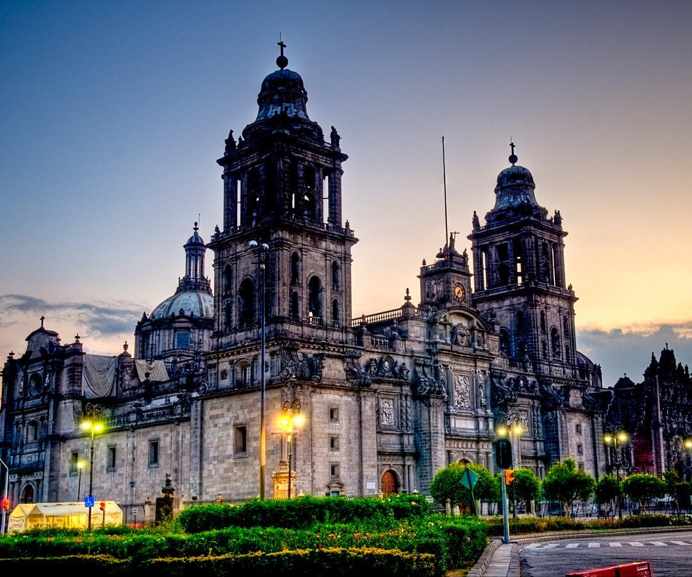

Metropolitan Cathedral

Day 2 Sunday, April 2
Paseo de la Reform and sites
Chapultepec Park, Chapultepec Castle and others
Meals: Breakfast

We will transfer to Paseo de la Reforma where we can walk among the “chilangos” (people belonging to Mexico City) who come out in droves with their children and pets, and bicycles and skateboards as the whole Paseo is closed to traffic from 8am to 2pm every Sunday. It is chance to visit landmarks and a wonderful opportunity to spend time with locals. This tradition has now lasted for 10 years. We will enjoy lunch in one of the many places available in Paseo de la Reforma.

After lunch, we will join some of the walkers as we enter Chapultepec Park, an oasis and one the loveliest places to visit in Mexico City. We reach Chapultepec Castle. Built in 1725, it had several uses until it became the official residence of Maximilian I and his wife, Empress Carlota. It presently holds the National Museum of History. We will have time to explore or visit other sites in the area including the Botanical Gardens or the Museum of Modern Art.

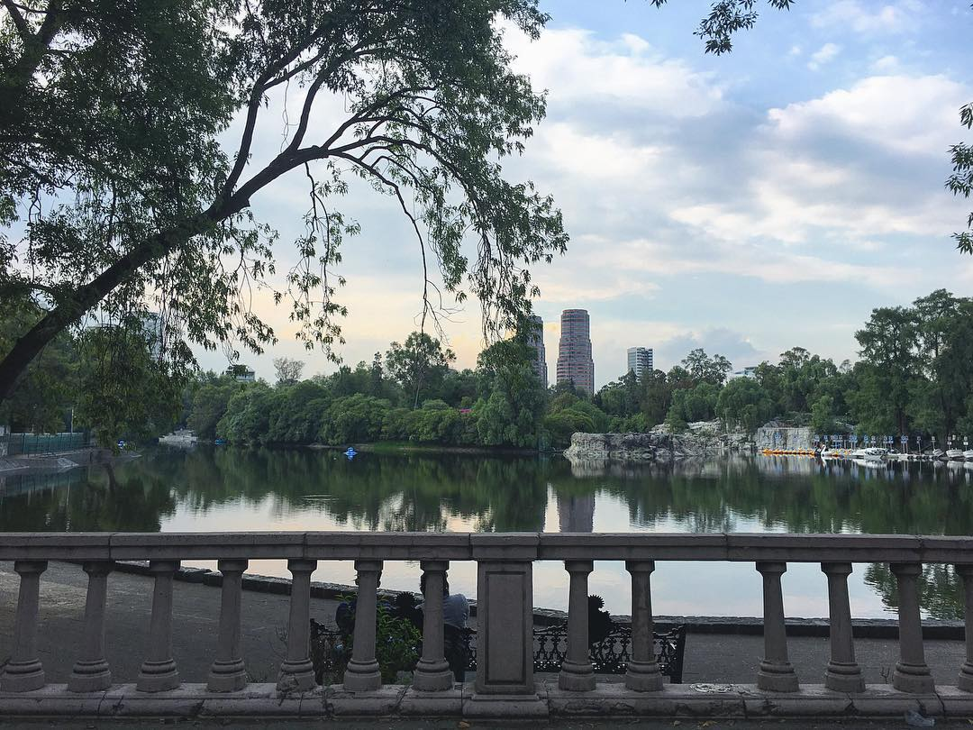

Chapultepec Park

Museum of Modern Art
Mexico’s most important public modern art museum has a wide-ranging collection of Mexican art from recent decades. The dark glass building, designed by Pedro Ramírez Vásquez, contains four spacious exhibition spaces, three of which are dedicated to rotating exhibits of generally excellent quality and a fourth space for showing selections from the permanent collection. The collection includes works by Diego Rivera, José Clemente Orozco, Rufino Tamayo, Manuel Álvarez Bravo, and Dr. Atl. One of the galleries contains Frida Kahlo’s largest work, Las Dos Fridas, in which twin portraits of the artist are joined by arteries looping from the exposed hearts of each figure. Also notable are 1920s paintings by Ángel Zárraga.

Day 3 Monday, April 3
Program: Acolman
Archaeological Zone of Teotihuacán
Sanctuary of the Virgin of Guadalupe
Meals: Breakfast and Lunch

This morning we travel outside of Mexico City for a full day excursion. Our first stop will be at the Augustinian Church and ex-Convent of San Augustin in Acolman. An inscription in the façade reads “This work was finished in the year 1560, during the reign of the King Don Felipe, our lord, son of the Emperor Carlos V, and governing this New Spain his illustrious (the second) viceroy, Don Luis de Velasco, with whose favor it was built”. Acolman established itself as one of the earliest educational centers where the Augustans learned and translated local languages for the indoctrination of the local population. This fortress-like convent is an important example of the plateresque style with elements first shown in the New World.

We continue on to the ancient city of Teotihuacán, one of the largest and most impressive archaeological sites in the Americas. Recently in the news, as archaeologist completed the excavation of a deep underground tunnel closed for 1,800 years and containing over 75,000 artifacts which runs to the very epicenter of the Temple of Quetzalcoatl or Plumed Serpent. During the city’s heyday it was Mesoamerica’s most powerful social and political hub. The structures were built between 100 B.C. and A.D. 250, and accommodated 200,000 people at its height, rivaling its contemporary, Rome. Whatever civilization produced Teotihuacán lasted roughly until the 7th century A.D., but despite its technological complexity left behind no writing system. Around A.D. 750 the city was abandoned and set afire, perhaps in a war with a smaller rival city. The pyramids, citadel, temples, palaces, plazas and paved streets remained deserted and forgotten until the Aztecs arrived in A.D. 1200.

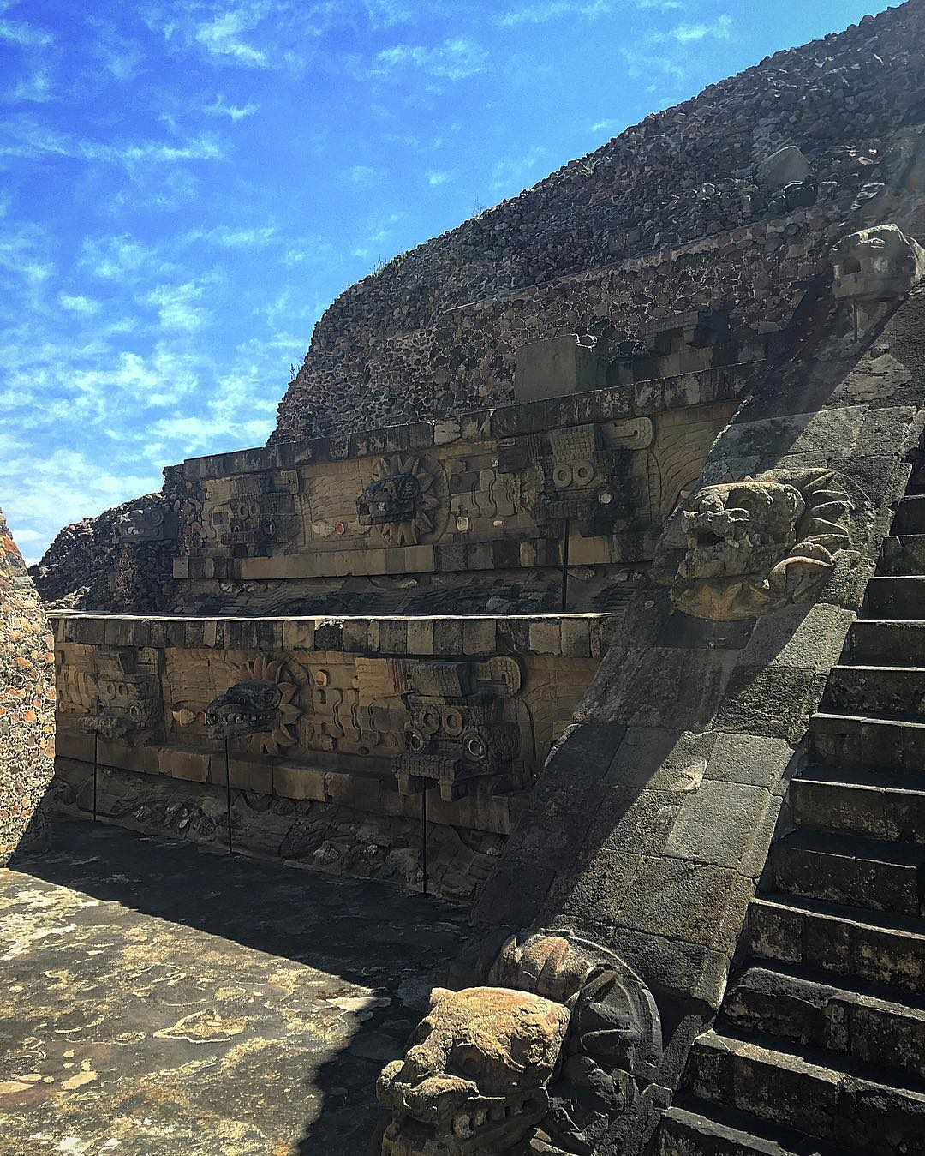

Teotihuacán

On our return to Mexico City we will visit the Sanctuary and Basilica of the Virgin of Guadalupe. Over 20 million people visit her annually and the new Basilica built in the 1970´s holds over 50,000 people who can attend mass every hour on the hour, 24 hours a day.

Day 4 Tuesday, April 4
Program: National Palace
Metropolitan Cathedral of Mexico City
Archaeological Zone of the Great Temple of Tenochtitlán
San Ildefonso College & The Secretary of Education Building
Meals: Breakfast and Lunch

Our day start just a couple of blocks from our hotel where our expert guide will take us to these sites. After lunch you are free to explore on your own or do some people watching in the Zocalo.

National Palace
Originally one of Hernán Cortés’s many residences the palace was built on the site of Aztec Emperor Moctezuma II’s castle and rebuilt in 1628. Here we will see one of Diego Rivera’s best-known murals on the walls above the palace’s central staircase, depicting his vision of Mexico’s history.

Metropolitan Cathedral
The largest colonial cathedral in the Americas, built partially on the ruins of the Templo Mayor. The Cathedral took 2-1/2 centuries to complete, from 1573 to 1813, and the quantity of artistic detail is almost impossible to fully absorb. The Altar de los Reyes houses a 25-meter-high golden retablo of ornate baroque complexity, and each of the 14 side chapels hold impressive artistic works.

Templo Mayor Museum of Tenochtitlán
The excavated site of the holiest shrine of the Aztecs, which was razed by the Spanish conquistadors in the 16th century, has been partially reconstructed in the last 30 years. At one time it consisted of a walled complex of 78 buildings built on different levels, crowned with two tall pyramids. Today the excavated site covers four city blocks, and includes an archaeological museum with a display model of the Aztec city and some 7,000 artifacts found at the site.

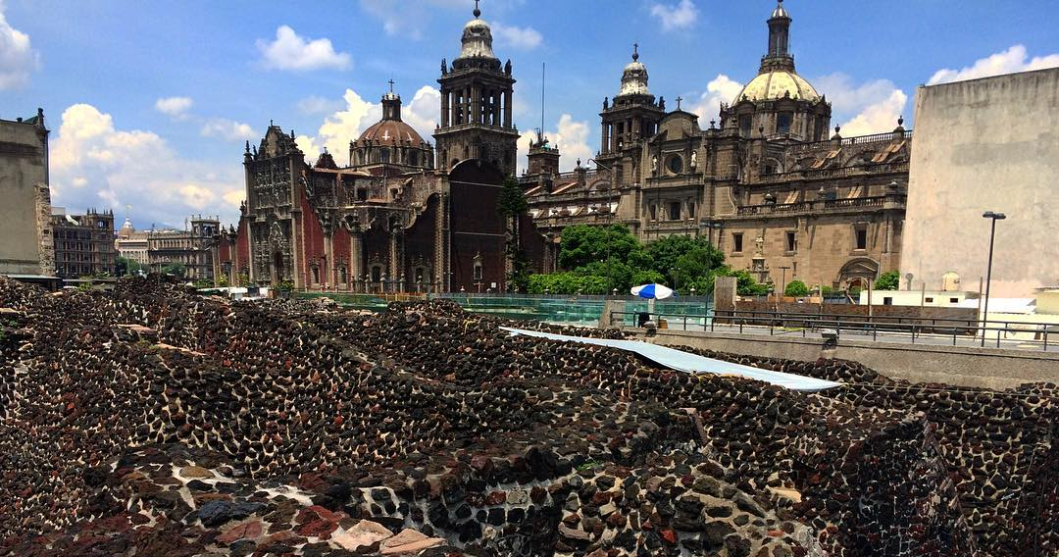

The Great Temple of Tenochtitlán

San Ildefonso College and the Secretary of Education Building
Housed in a former convent, its courtyard is decorated with a great series of more than 200 Diego Rivera murals, dating between 1923 and 1928 that cover over 1,500 square meters (16,146 sq. ft.) of wall space. Other artists did a panel here and there, but the Rivera murals are the most outstanding.

Day 5 Wednesday, April 5
Program: Soumaya Museum
Jumex Museum
National Museum of Anthropology
Rufino Tamayo Museum
Meals: Breakfast and Lunch

A day dedicated to art where we will have a leisurely pace and enjoy lunch at the museum.

Soumaya Museum
Anchoring the new development of Plaza Carso in Polanco, this amazing structure hold the eclectic art collection of more than 70,000 objects belonging to Carlos Slim, including the largest private collection of Rodin’s sculptures.

Jumex Museum
The building, by the British architect David Chipperfield, exhibits portions of one of the largest private contemporary art collections in Latin America. Fundación Jumex’s art collection, has actively sought to present a global vision of contemporary art, examining it both in breadth and in depth, with a special emphasis on important Mexican and international contemporary artists. Its goal is to collect and preserve representative works of art made after 1950.

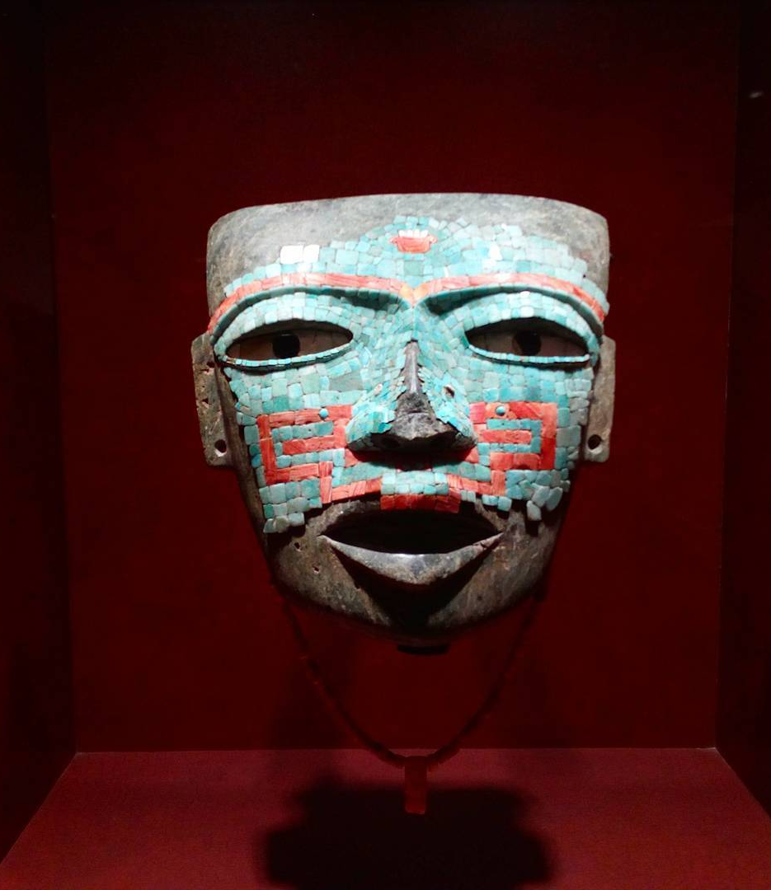

National Museum of Anthropology

National Museum of Anthropology
This is the largest museum in Latin America, and one of the great anthropological museums of the world. We will see superb archeological exhibits from early Mesoamerican societies — beginning with the Teotihuacanos, Toltecs, Olmecs, Zapotecs, and others right up to the Aztecs — as well as ethnological displays on Mexico’s current Amerindian groups — including the Huichol, Cora, Purépecha, Otomi, Nahua, and different groups from the Sierra de Puebla, Oaxaca, and Gulf of Mexico regions. Apart from its treasures, Pedro Ramirez Vasquez’s building itself is an impressive work of art, with its understated exterior and dramatic central patio. In the middle of the patio, a sheer curtain of water flows from a huge overhang supported by a concrete column with sculpted reliefs depicting events in Mexican history.

Museo Rufino Tamayo
The Tamayo was created by one of the great Mexican artists of the 20th century, a Zapotec Indian born in Oaxaca in 1899. Heavily influenced by his indigenous roots, Rufino Tamayo gained fame in the 1950s (when he was living in New York) for his dramatic use of colors, particularly the earth tones from his native state. In 1981, he and his wife Olga, donated this museum along with a fabulous collection of modern art. Salvador Dalí, Max Ernst, Gunther Gerzso, Alberto Giacometti, Willem de Koening, René Magritte, Joan Miró, Andy Warhol, and many others are represented. Tamayo died in 1991 at the age of 91.

Day 6 Thursday, April 6
Program Architectural tour of Mexico City including Barragán House and UNAM
Panoramic tour of neighborhoods
Meals: Breakfast and Lunch

Mexico City is experiencing an architectural revival – this “Me-Mo” or “Mexican moment”, a term used by local architects, is bringing world attention to this metropolis, including the new plans for the expansion of the Mexico City airport, and the many examples of the exciting work that has been produced in the last few years. Our local guide will take us on a panoramic tour of the various neighborhoods where we will admire modern and contemporary works, including the various buildings that comprise the National Autonomous University of Mexico.

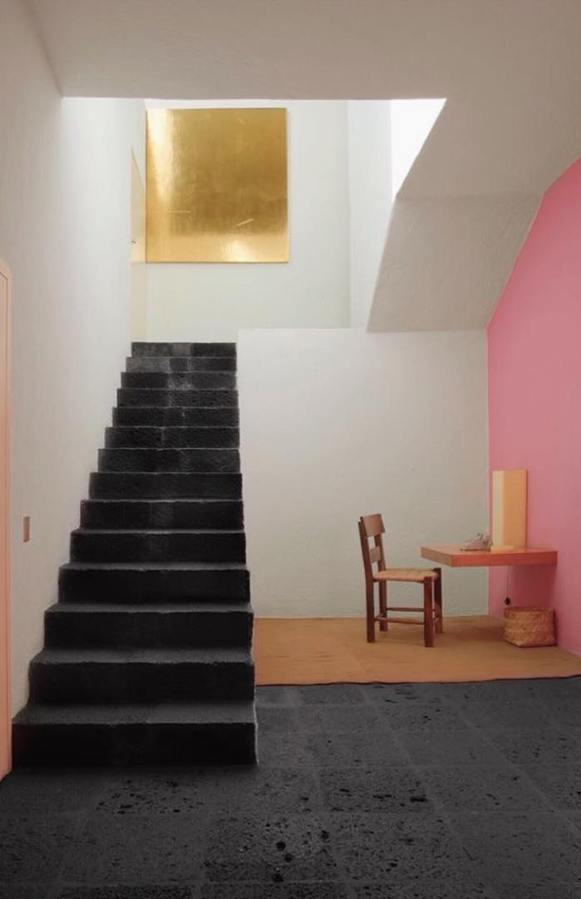

Luis Barragán House & Studio

Tacubaya Neighborhood
Luis Ramiro Barragán Morfín (March 9, 1902 – November 22, 1988) was a Mexican architect and engineer. His work has influenced contemporary architects through visual and conceptual aspects. Barragán won the Pritzker Prize, the highest award in architecture, in 1980. Luis Barragán committed to architecture as a sublime act of the poetic imagination. He has created gardens, plazas, and fountains of haunting beauty—metaphysical landscapes for meditation and companionship. We will visit his home and studio, a jewel of the twentieth century, and considered by UNESCO as a World Cultural Heritage Site.

We will explore Tacubaya with a drive to the Ermita Building, one of the first skyscrapers of the city and a good example of Art Deco in the country; the Alameda de Tacubaya with its obelisk, palm trees and gardens; the Temple and Ex Convent of Santo Domingo, which survives its original cloister; the Ball House, built in the eighteenth century and is now a museum; and Lira Park, with its magnificent arch designed by the Italian architect Javier Cavallari.

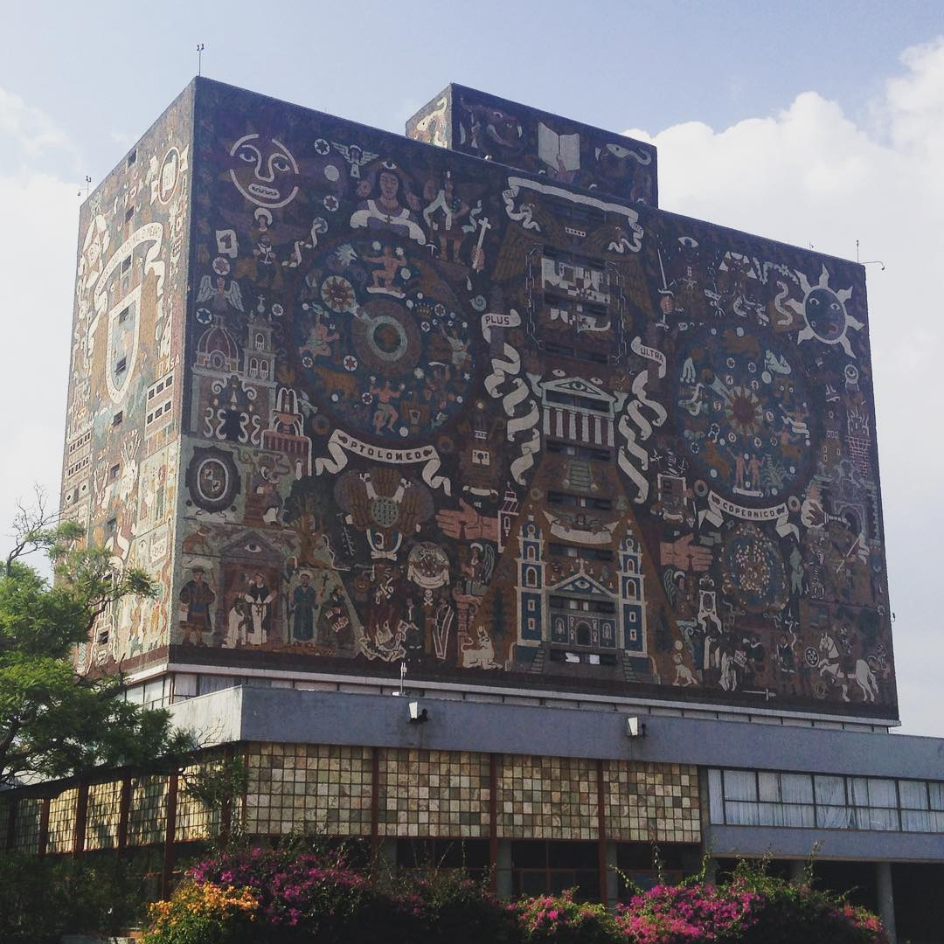

National Autonomous University of Mexico

UNAM
The National Autonomous University of Mexico is the largest university in Latin America and considered by many to be the leading university of the Spanish-speaking world. Its preceding institution the Royal and Pontifical University of Mexico was founded on 21 September 1551 by a royal decree of Charles V, Holy Roman Emperor and brought to a definitive closure in 1865 by Maximilian I of Mexico. Its campus is one of the largest and most artistically detailed. It is a UNESCO World Heritage site that was designed by some of Mexico's best-known architects of the 20th century. Murals in the main campus were painted by some of the most recognized artists in Mexican history.

Day 7 Friday, April 7
Program: Popular Art Museum
Franz Mayer Museum
National Museum of Art
Meals: Breakfast and Lunch

Popular Art Museum
Opened in 2006, this museum is housed in a renovated 1928 art deco building just south of the Alameda. The permanent exhibition, covering two floors, contains a myriad of sculpture, textiles, toys, lacquer ware, silver art, woodcarvings, glass, leatherwork, weavings, and much more. The other two floors are dedicated to temporary exhibitions. The gift shop has excellent quality goods, but do not expect any bargains.

Franz Mayer Museum
The Franz Mayer Museum, located in an eighteenth-century building, houses the finest collection of decorative arts in Mexico. For four centuries it functioned as a hospital. Over the last forty years it has undergone diverse modifications that have altered its architectural style, in order to grant it new functions. Mr. Mayer was born in Mannheim, Germany, he moved to London and the United States before arriving in Mexico in 1905. In 1920, he married María Antonieta de la Macorra and later became a widower without descendants. He became a Mexican citizen on December 29th, 1933. This eclectic museum contains the carefully and tastefully displayed applied arts collection of Mr. Mayer. Works include 16th- through 19th century Mexican ceramics, antique rebozos (Mexican shawls), religious articles, furniture, textiles, silver and gold pieces, clocks, and even cocinas poblanas (tiled Puebla-style kitchens). The museum also contains a few European renaissance paintings. We will arrive at the Franz Mayer Museum for a tour of highlights from the collection of decorative arts and paintings from the Spanish colonial period and the 19th century.

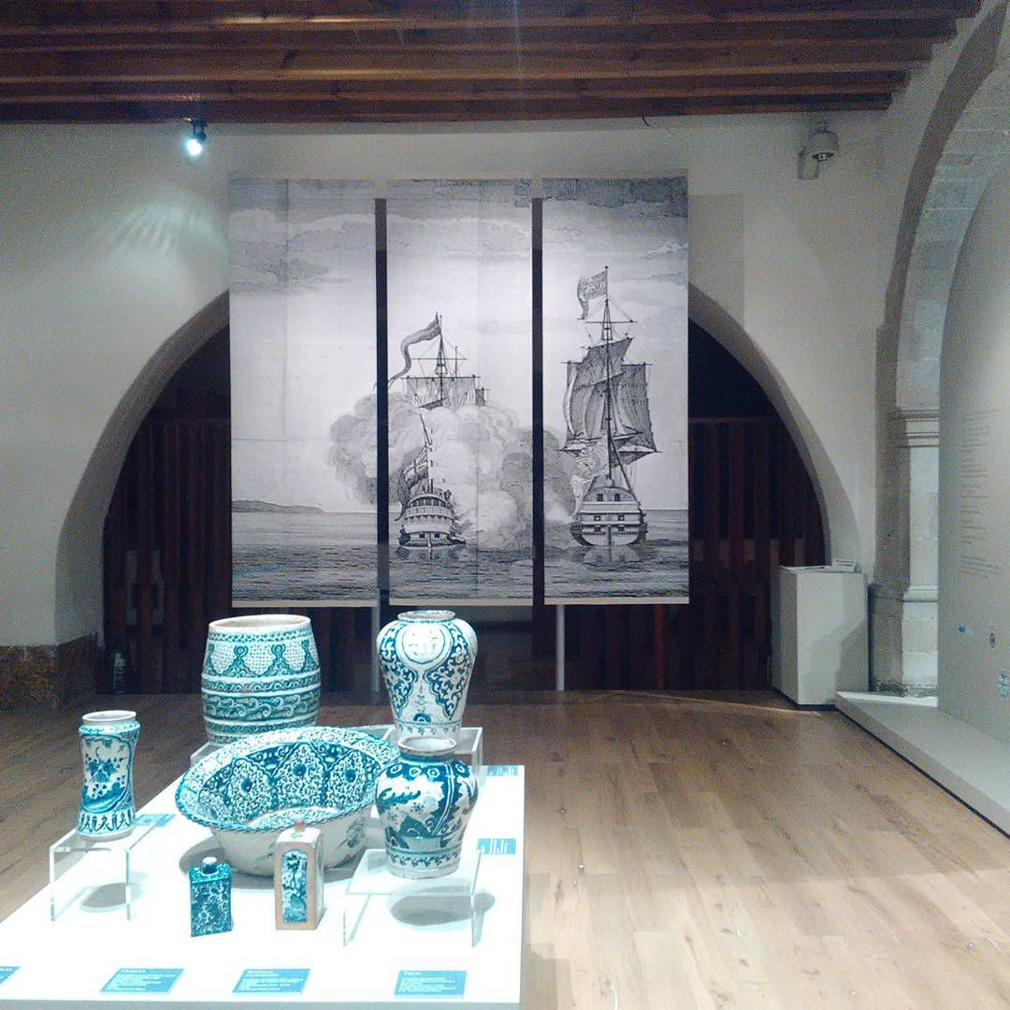

Decorative Arts at the Franz Mayer Museum

National Art Museum
This austere gray palace, built in 1910, was converted into a museum in 1982. Its cool, beautiful interior houses an overview of Mexican art dating from the early colonial period to the mid-20th century. Among the notable artists featured are colonial painters Miguel Cabrera, Cristóbal Villalpardo, and Luis Juárez; 19th century painters Juan Cordero, José María Velasco, and Ramón Sagredo; the 20th century’s Diego Rivera, Frida Kahlo, Rufino Tamayo, and others.

Day 8 Saturday, April 8
Program: Coyoacán Frida Kahlo Museum
Leon Trotsky Museum
San Ángel Anahuacalli
House- Studio Museum of Diego Rivera and Frida Kahlo
Meals: Breakfast and Lunch at the beautiful San Ángel Inn

Coyoacán
Coyoacán or “the place of the coyotes¨ has been important in the history of Mexico. In pre-hispanic times it provided water to the great Tenochtitlán; during the Conquest it was the place Hernán Cortés chose to build his palace and in modern times, it was the meeting place for intellectuals and artists. Coyoacán was once a colonial village separated from Mexico City proper by farmlands and lakes, and it remains one of the most traditional neighborhoods of the “Distrito Federal” or “D.F.” or what the locals call Mexico City. The plazas and narrow cobbled streets, once part of huge haciendas and convents, invite strolling, and the plazas fill with street vendors selling handcrafts.

Frida Kahlo Museum
The artist was born in this house to a German father and Mexican mother in 1907. Now acclaimed by critics and collectors worldwide, Kahlo painted for years in the shadow of her famed muralist husband, Diego Rivera. She suffered a crippling injury in her early years, and her art suggests a stoic life full of pain and self-absorption. A selection of Kahlo’s personal art collection is on display — including pre-Hispanic artifacts and Mexican folk art, as well as works by well-known artists such as José María Velasco, Paul Klee and Rivera. Particularly interesting are Kahlo’s self-portraits, which combine her own self-examination with her fascination with communist ideology and Amerindian folkways.

Leon Trotsky House Museum
We travel back in time and visit the house in which Leon Trotsky lived with his wife Natalia Ivanovna Sedova from 1939 to 1940, and where the Russian dissident was murdered. The house has been kept as it was at that time, especially the study in which a Catalan, Ramón Mercader killed Trotsky with an ice axe to the back of the head. Around the house is a garden where you can still appreciate the high walls with watchtowers.

San Ángel
Mexico City’s Secretary of Tourism recently named the San Ángel neighborhood a Barrio Mágico (Magic Neighborhood). San Ángel's cobblestone streets, plazas, gardens and elegant estates are reminiscent of the neighborhood’s rich colonial past. This magical district, located south of Mexico City, conserves an elegant and stately air, which mingles old houses, history, legends, art and gastronomy. Throughout the year the San Ángel neighborhood hosts several festivals and cultural celebrations including the San Ángel Flower Festival and the Fiesta de la Virgen del Carmen. San Ángel’s Bazaar Sabado (Saturday market), held in a two-story building located just off the main Plaza San Jacinto, is an ideal place to browse an array of quality handicrafts from across Mexico.

House-Studio of Diego Rivera and Frida Kahlo
One of the most important cultural landmarks of Mexico City, it is considered the first construction of the modern movement in the American continent. It was built by the Mexican architect Juan O’Gorman, a recent graduate of the UNAM, who designed spare, rectilinear buildings following the Functionalist Style of architect Le Corbusier.

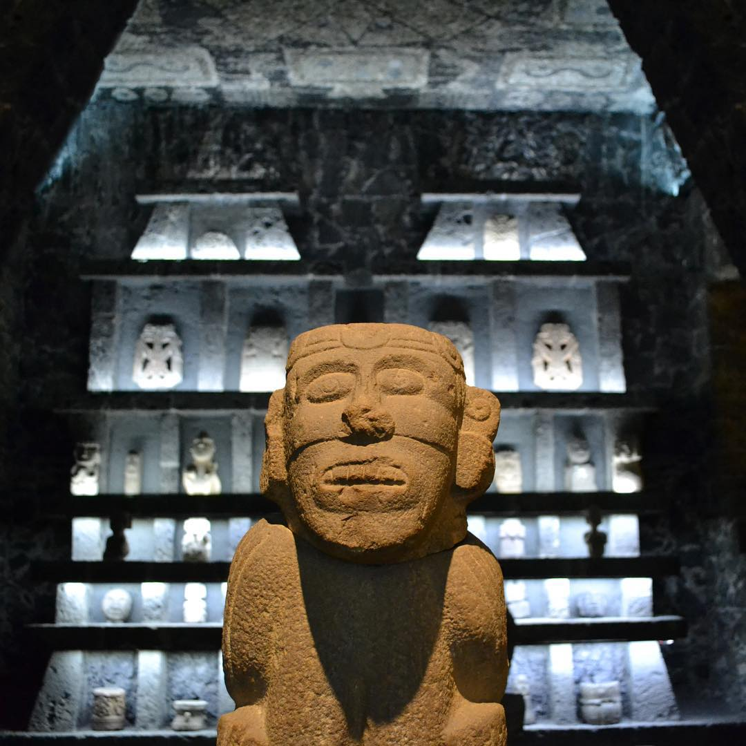

Anahuacalli Museum

Anahuacalli Museum
We will continue to the Anahuacalli Museum for a guided tour of this fascinating house, designed by Rivera in the last years of his life and filled with his prodigious collection of pre-Colombian art. This fascinating and unusual building was built by architects Juan O’Gorman, Heriberto Pagelson and Rivera’s own daughter Ruth and completed it after his death. Built of black volcanic rock, it takes the form of a pyramid. The word Anahuacalli means “house of water”.

Day 9 Sunday, April 9
Program: Lagunilla Market
La Merced Market

La Ciudadela Market
Meals: Breakfast and Lunch

Lagunilla Market
We begin our walk to an assortment of markets including the famous “La Lagunilla” market, an open-air market held every Sunday where you can find rare objects, curiosities (Mexican and other), useful or useless things that you should not miss if you are a collector. You can also find old Mexican crafts, books, photographs, coins, records, clothing, and other. If you are not interested in shopping, it is a great place for people watching.

La Merced Market
Entering La Merced and seeing the vastness of this densely populated market can be a bit overwhelming. There are many buildings that make up a dizzying maze of vendors that sprawl across an area about four city blocks long by two blocks wide. This area was an entry and exit point to the city after the Spanish conquest of the Aztec empire, and appropriately became a point of trade. By the turn of the 19th century, the entire neighborhood was essentially one giant market, and in 1863, the first permanent building to house it was constructed. Since then it has endured and expanded, only to be outdone by Central de Abastos, the largest market of its kind, which was built to alleviate crowding at La Merced in the early 1980s.

La Ciudadela Market
The Ciudadela Market is a traditional style Mexican market that specializes in the sale of Mexican handcrafts and folk art, located in the southwest corner of the historic center of Mexico City. The market is the first of its kind in the country, established just before the 1968 Summer Olympics to promote this aspect of Mexico’s cultural heritage.

Day 10 Monday, April 10
Program International Departures
Check out and transfer to the airport
Air Schedule Depart Mexico City 10.55am – United #1025 – Arrive Houston 1.18pm
Depart Houston 5.40pm – United # 786 – Arrive Albuquerque 7.00pm

HOTEL INFORMATION Hotel Hampton Inn Centro Histórico or similar
5 de Febrero # 24
Mexico DF

COST OF THE TOUR $2,495.00 per person double occupancy including airfare
$650.00 supplement for single occupancy

$2,195.00 per person double occupancy (no airfare included)
(Please see Important Notice- Airfare below)

INCLUDED:
- Round trip airfare from Albuquerque to Mexico City ** (very important, see below)
- 9 nights’ accommodation in Mexico City
- American breakfast daily and eight lunches
- Transfer from and to the airport in Mexico city
- Transportation by chartered bus on: Day 3, Day 5, Day 6 and Day 8, as per itinerary
- Water on board the coach on traveling days
- Entrance fees to all sites indicated in the itinerary
- English-speaking local guides

NOT INCLUDED:
- Items of personal nature
- Tips to driver and guides

REGISTRATION, PAYMENT SCHEDULE AND CANCELLATION PENALTIES:

To register for this tour, please contact Rosa Carlson to check availability
Fill out our Booking & Release Form, enclose a photocopy of your passport and your deposit check (no credit cards) and mail them to:

Journeys International, Inc.
49 Verano Loop
Santa Fe NM 87508

For any questions or comments please contact Rosa Ramirez Carlson at: (505) 310-1863
info@journeys-international.com or her personal email: carlsonrosa@hotmail.com

Payment Schedule:

DEPOSIT: $500.00 at time of booking
FINAL PAYMENT: DECEMBER 27TH 2016 IF USING GROUP AIRFARE (See Below)
FINAL PAYMENT JANUARY 15TH 2016 IF NOT USING GROUP AIRFARE

Cancellation Schedule:
After deposit $150.00 administrative fee
After final payment 100% of the total tour price

** IMPORTANT NOTICE – AIRFARE
We have been able to obtain a great rate and flight schedule for the tour, however if you want to take advantage you must pay for the tour in full no later than December 27th, 2016. If we do not have 10 people traveling together on that date, the cost of the tour will not include the airfare and each traveler will be responsible for purchasing airfare to Mexico City.

Travel Insurance: Purchase of trip cancellation insurance is strongly recommended. If you have any pre-existing conditions for which you would like coverage, most companies require that you must purchase the insurance within 14 days of your first payment for the tour. You can purchase coverage just for the amount of your deposit and later increase your coverage when the final payment is made. In addition, many health insurers, including Medicare, do not provide coverage for insured persons traveling abroad. Affordable health insurance for overseas travelers is readily available with companies such as Medex, Travel Guard, Allianz Travel Insurance and similar companies. Please contact Rosa Ramirez Carlson is you have any questions or need assistance in selecting insurance.

