FOLK ART IN PERU AND

THE ART OF COMMUNITY

LIMA, AYACUCHO, AREQUIPA, COLCA CANYON

With an extension to CUSCO AND MACHU PICCHU

MARCH 18TH TO MARCH 31ST, 2020

The FRIENDS OF FOLK ART, a committee of the Museum of New Mexico Foundation, invites you to join Dr. Amy Groleau, Curator of Latin American & Caribbean Collections and Rosa Ramírez Carlson, a native Peruvian and owner of Journeys International, Inc., for an incredible tour to Lima, Ayacucho* in the Andes of Central Peru, Arequipa and the Colca Canyon.

The tour will visit the historical neighborhoods of Barranco and Miraflores in Lima before flying to Ayacucho, a major center for folk art in Peru. With folk art traditions in wood, Huamanga stone carvings, retablos, Sarhua boards (traditional wood paintings), silver filigree, pottery, leather work and incredible weavings, you’ll see why this area is known as Peru's cultural center of indigenous art creation. We will learn of the rich traditions of folk art practiced by generations of artisans as we visit them in their studios and workshops. Along with the other sites we will visit the Museum of Memory, started by a group of women and survivors of the violence of the terrorist movement Shining Path or Sendero Luminoso.

Our tour will continue to Arequipa, a jewel of colonial architecture, founded in 1540. We will visit the Templo and Convent of Santa Catalina, the Cathedral and other sites. Our explorations will take us to one of the most magnificent sites in Peru, the Colca Canyon. Considered the second deepest canyon in the world, it is the home of the Collaguas and Cabanas, pre-Inca groups living in opposite sides of the canyon, which have preserved their culture, customs and art. An optional tour to CUSCO and MACHU PICCHU will be offered at the end of the tour.

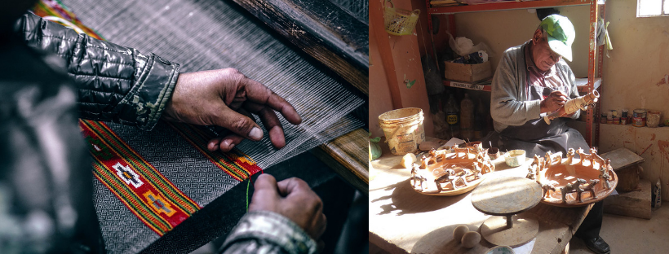

*Dr. Groleau will accompany the tour in Lima and Ayacucho. Mrs. Carlson will continue with the group to Arequipa and the Colca Canyon.

DAY BY DAY ITINERARY

Day 1 – Wednesday, March 18
We will depart Albuquerque via American Airlines flight #2273 leaving Albuquerque at 6.25pm arriving at Dallas/Ft Worth at 9.15pm. There we will board American Airlines flight #909 leaving Dallas/Ft Worth at 10.22PM.

Day 2 – Thursday, March 19 – Lima (L)
We arrive in Lima at 5.24am. After clearing customs and immigrations we will be met and taken to our hotel where your rooms will be available. After check in and some rest and relaxation we will meet in the lobby for a group lunch. After lunch we will visit the extraordinary textile collection at the Museo Amano in Miraflores. Overnight at Mercure Ariosto Miraflores or similar

Day 3 – Friday, March 20 – Lima (B L)
Our full day tour will start at the heart of Colonial Lima. Founded by Francisco Pizarro in 1535 it became the most important South American city of the period. We will visit Lima’s most imposing colonial churches and mansions including the Government Palace, the Plaza de Armas, the City Hall, the Cathedral and the 17th century San Francisco Monastery. After lunch, we will continue to the Larco Herrera Museum. Founded in 1926, it is located in a unique 18th-century, vice-royal mansion built atop a 7th century pre-Columbian pyramid, and surrounded by beautiful gardens. The museum showcases a remarkable series of galleries that chronicle 3,000 years of Peru's pre-Columbian history. Overnight at Mercure Ariosto Miraflores or similar

Day 4 – Saturday, March 21 – Lima (B L)
Today we will spend a full day between Miraflores and Barranco, two of the most interesting neighborhoods of Lima. Barranco is bohemian with many art galleries, a contemporary Art Museum, cafes, restaurants and bars. We will visit the studio of Amapolay whose work is part of MOIFA’s exhibition and the renowned gallery Las Pallas, whose owner Mari Solari has collaborated with MOIFA in previous exhibits. We will enjoy lunch and allow free time for private visits to the Pedro de Osma Museum and other sites. Overnight at Mercure Ariosto Miraflores or similar

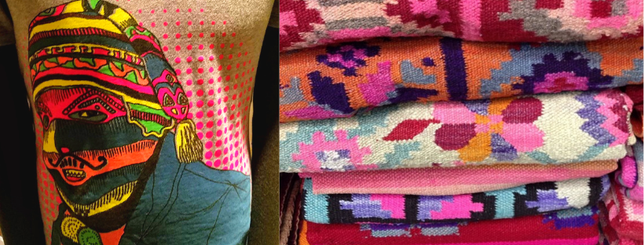
Amapolay & Las Pallas

Day 5 – Sunday, March 22 – Ayacucho (B)
Transfer to the Lima Airport
Domestic flight from Lima to Ayacucho LA#2183 3.08pm 4.10pm
Upon arrival we will be taken to our hotel. After check-in and relaxation we will have an orientation walking tour of the center and surrounding areas. Overnight at Hotel DM Ayacucho or similar

Day 6 – Monday, March 23 – Ayacucho (B L)
This morning our tour begins at the historic center of Ayacucho. Our tour will visit the PlazaMayor, colonial houses such as Casa Castilla, Casa Zamora, the Catedral and if available, the beautiful churches of San Francisco, Santa Teresa, and San Cristóbal. After lunch we will drive to the neighborhood of Santa Ana where we will appreciate the richness of the popular art. We will visit the workshop of artists including Alejandro and Alexander Gallardo, the Sulca family, Rosalia Tineo Torres, Jose Galvez and Saturnino and Vilma Oncebay as well as other artists. Overnight at Hotel DM Ayacucho or similar.

Day 7 – Tuesday, March 24 – Ayacucho (B L)
After breakfast we will visit the pre-Inca ruins of Wari and Pampas of Ayacucho. In 1550, the chronicler Pedro Cieza de León recounted the discovery of several monumental structures whose architecture differed from previously discovered Inca structures. He was describing Wari, the capital of the first Pan-Andean state, from the pre-Inca period (between 600 and 1000 A.D.). Wari is an example of urban planning using pre-Hispanic engineering techniques. The urban core, which spanned some 1,000 acres and at its peak was home to some 40,000 inhabitants, was strategically located in a position with rapid access to the coast and the inland jungle, mid-way between the northern and southern mountain ranges, where they established administrative centers and colonies.

After lunch, we will continue to Quinua, a village located 25 miles from Ayacucho, where pottery is the town’s main activity. The quality of the red and cream-colored clay lends these works a unique characteristic. Here we will visit the workshops of Victor Huaman Quinua, Mamerto Sanchez and Artemio Poma. Overnight at Hotel DM Ayacucho or similar.

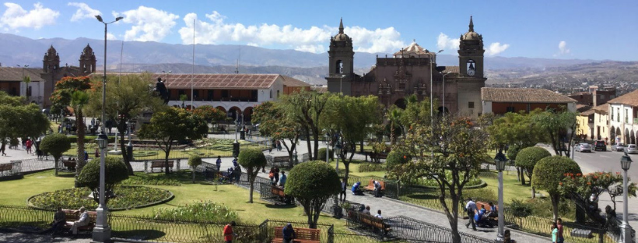
Ayacucho

Day 8 –Wednesday, March 25 – Ayacucho (B)
Our tour this morning will begin at the Museo de la Memoria, where we will meet some of its principals and volunteers. This museum addresses the incredible violence experienced in Peru between 1980 and 2000, and particularly, the political and social situation in Ayacucho where the Shining Path movement started. After lunch, we will visit the Mercado Artesanal Shosaku Nagase where we will have the opportunity to visit with local artists and appreciate their work including the workshop of Edwin del Pino and many others. Overnight at Hotel DM Ayacucho or similar.

Day 9 – Thursday, March 26 – Arequipa (B)
This morning is free to further explore the town, to do some last minute shopping or to pack. You will be taken to the airport in time to check-in for your flight to Lima.

Domestic flight from Ayacucho to Lima LA#2182 4.40pm 5.35pm
Domestic flight from Lima to Arequipa LA#2103 7.57pm 9.26pm

Upon arrival in Arequipa we will be met and taken to our hotel.
Overnight at Casa Andina Select Arequipa or similar

Day 10 – Friday, March 27 – Arequipa (B L)
Our morning tour will begin at the Templo y Convento de Santa Catalina, built in 1580 and eventually expanded to include cloisters, plazas, streets, tiled roofs, and cobblestone paving; this walled citadel served as a totally enclosed convent for nuns from the city's most distinguished families. After this visit we cross the beautiful colonial Plaza de Armas and visit the Cathedral as we continue to the Iglesia de la Companía to admire its incredible dome. The tour continues as we explore the neighborhoods of Cayma and Yanahuara where we will have lunch. Arequipa is the best place to appreciate many forms of folk art including alpaca and vicuña textiles, leather work, sillar stone goods, woodwork, furs, musical instruments, excellent straw hats, etc. The afternoon is free to explore this beautiful city. Casa Andina Select Arequipa or similar.

Day 11 – Saturday, March 28 - Colca Valley Arequipa (B L)
We will travel out of Arequipa to make our way to the Colca Canyon, one of the deepest canyons in the world. The trip begins as the winding road takes us through beautiful scenery passing between the Misti and the Chachani volcanoes. We will travel through the Aguada Blanca National Reserve, where elegant vicunas wander the high plains. We leave the main road and stop in the enchanted village of Sibayo. We arrive in the afternoon at the village of Chivay. Overnight at Hotel Casa Andina Standard Colca or similar.

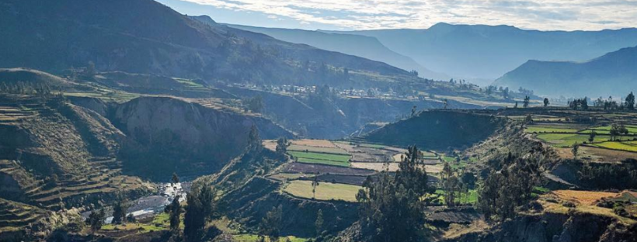
Colca Canyon

Day 12 – Sunday, March 29 – Colca Valley Arequipa (B L)
Early in the morning, we leave to the "Condor Cross ", the best point for a breathtaking view of the Colca Canyon and if the weather allows, we will have the chance to enjoy the majestic flight of the Andean Condor, which is the biggest bird in the world. Then we will visit the Hanging Tombs at Choquetico before continuing on to the towns of Maca, Achola and Yanque and its lovely white church. After lunch we will meet some of the artisans of the Colca Canyon, members of the Collahua and Cabana cultures, who produce stitch knitting using alpaca threads to make polleras (skirts) and many other items. This tradition is found throughout all the towns of the Colca Valley, using natural motifs such as leaves, flowers, birds and plants as well as geometric designs. Overnight at Hotel Casa Andina Standard Colca or similar.

Day 13 – Monday, March 30 – Arequipa (B D)
After breakfast we will walk to the local market and later prepare to depart for Arequipa. Our journey will start as we begin our ascent out of the canyon over the Pata Pampa pass (16,100 feet) and travel four hours back to Arequipa. Casa Andina Select Arequipa or similar

Day 14 – Tuesday, March 31 – Arequipa
After a leisure morning with time for last minute explorations, shopping or packing we will have a transfer to the airport for our flight back to Lima.
Domestic Flight from Arequipa to Lima: LA#2140 4.49pm to 6.23pm
Our international departure will be on American Airlines flight # 988 leaving Lima at 11.54pm and arriving in Dallas/Ft Worth at 7.22am. There we will connect to American Airlines flight # 2420 leaving Dallas/Ft Worth at 9.05am and arriving in Albuquerque at 9.58am. Welcome home!

Elevation:
Lima Sea level
Ayacucho 9,058' Feet Above Sea Level
Arequipa 7,661' FASL
Cusco 11,152' FASL
Sacred Valley 9,373' FASL
Machu Picchu 7,970' FASL

PLEASE NOTE: The cost of the tour is subject to change due to currency fluctuations or changing fuel surcharges. It is possible that changes to the above itinerary/program may be necessary. If so, whatever is altered will be replaced by its equivalent.

COST OF TOUR
Pricing based on a minimum of 15 passengers: $5,525.00 per person
Double Occupancy: $750.00 single occupancy

Cost of tour includes:
- $420.00 donation to the Museum of International Folk Art
- Round trip international airfare from Albuquerque to Lima via American Airlines
- Four domestic flights within Peru
- Experienced English-speaking guides and drivers throughout the trip
- All entrance fees as per itinerary
- Lodging and transportation within Peru
- Meals as specified in the itinerary

Not included:
- Drinks and beverages, and meals not listed as included in price
- Items of personal nature
- Tips to drivers or guides

General Terms and Conditions:

Mrs. Rosa Ramírez Carlson of JOURNEYS INTERNATIONAL, INC. is handling all the arrangements for this tour and will be happy to answer any questions.

Reservations for this tour can be made by calling Rosa at (505)-310-1863 or by sending an email to: info@journeys-international.com A deposit of $1,000.00 per person will be required to hold your space. Please send a check to: Journeys International, Inc., 49 Verano Loop, Santa Fe, NM 87508

FINAL PAYMENT IS DUE ON OCTOBER 18TH, 2019

After full payment cost of the tour is non-refundable. In case of cancellations, the following penalties will be applicable:

After deposit: $250.00 administrative fee
After October 18th, 2019 100% of the total tour price

Payment by check is preferred. Credit card payments will incur a 3% fee.

Notes: Price is subject to change due to currency exchange fluctuations or fuel surcharges. It is possible that changes to our itinerary may be necessary. If so, whatever is altered will be replaced by its equivalent.

Purchase of trip cancellation insurance is STRONGLY recommended. If you have any pre-existing conditions for which you would like coverage you must purchase the insurance within 14 days of your first payment. You can purchase coverage just for the amount of your deposit and later increase your coverage when the final payment is made. In addition, many health insurers, including Medicare, do not provide coverage for insured persons traveling abroad. Affordable health insurance for overseas travelers is readily available with companies such as Medex, Travel Guard, Allianz Travel Insurance and similar companies. Please contact Rosa Ramirez Carlson if you have any questions or need assistance in selecting insurance.

CUSCO AND MACHU PICCHU EXTENSION
Please note that the cost of this extension will depend in the number of people who sign up to participate and therefore it will be subject to change. Same cancellation penalties are applied.

DAY 1 LIMA / CUSCO
• Greet and transfer to hotel
• Half day city tour of Cusco
You will begin your tour as you enjoy the best view of the city of Cusco from atop Cerro Pukamoqo (Red Peak), a natural scenic overlook from which the outstretched arms of Cristo Blanco, a massive white statue of Christ, embrace the city in a benevolent gesture. You will then visit nearby Fortress of Sacsayhuamán, a colossal structure of enormous stones, carved and fitted together with incredible precision. The return will include a stop at Mercado San Pedro, the main market in Cusco, where you will appreciate the products of Cusco, overwhelming you with the sights, aromas, tastes, and colors of the region. Just a few blocks away, you will visit one of the most impressive buildings of Inca Empire: The Korikancha - a temple dedicated to the worship of the Sun God, whose interior walls were said to have been covered in gold. You will complete the day with a stroll through the Plaza de Armas, where you will visit the Cathedral and admire its exquisite vestibules and priceless paintings from the Cusco School of the 17th and 18th centuries.
Overnight Hotel Novotel or similar

DAY 2 CUSCO / SACRED VALLEY (B, L)
• Full day Sacred Valley tour
You will travel to Chinchero, a small and colorful town that owns a very important Inca archeological center built in the late XV century, as well as a beautiful and traditional church. You will visit the home of a local family where you will appreciate preserved weaving and textile techniques. On your way to Ollantaytambo, you will stop at the Raqchi vantage point to admire the area’s beautiful natural scenery, continuing on to Moray to see the enormous circular terraces that were used by the Incas as a botanical laboratory. The tour will also visit the Maras salt pans know for its salt around the world. Lunch will be served in a local restaurant. After lunch, you will continue to Ollantaytambo, one of the most imposing complexes of the Inca Empire and the site of one of the Spanish Conquistadors' rare strategic defeats. Famous for its terraced fields embedded into the hillsides, Ollantaytambo was an effective fortress as well as a religious center. The tour ends at the village located below the site which has been continuously inhabited since the 13th century. Overnight in the sacred valley TBD

DAY 3 CUSCO /MACHU PICCHU / CUSCO (B, L)
• Breakfast at hotel
• Transfer to train station
• Train to Machu Picchu
• Shuttle bus to the citadel and return
• PM- Guided tour of the Machu Picchu citadel (4 hours)
The ruins of Machu Picchu, rediscovered in 1911 by Hiram Bingham, are one of the most beautiful and enigmatic ancient sites in the world. While the Inca people certainly used the Andean mountaintop, erecting many hundreds of stone structures from the early 1400's, legends and myths indicate that Machu Picchu was revered as a sacred place from a far earlier time. Overnight Hotel Novotel or similar

DAY 4 CUSCO / LIMA (B)
• Breakfast at hotel
• Transfer to the airport for your flight to Lima

APPROXIMATE COST TO THE TOUR $1,565.00 PER PERSON DOUBLE OCCUPANCY
$1,818.00 PER PERSON SINGLE OCCUPANCY

Prices based on a minimum of 2 passengers. Includes airfare from Arequipa to Cusco and Cusco to Lima.

INCLUDED: Transfers and excursions on private basis
English-speaking guides
Accommodation and meals as per itinerary
Entrance fees to sites
Transportation to and from Machu Picchu
Flights to and from Cusco

NOT INCLUDED: Tips for porters, guides and drivers
Expenses of personal nature

